Exploring OpenAI API

Creating Simple tasks using OpenAI API

1. Email generation based on Amazon reviews using GPT-3.5
2. Code generation using GPT-3.5
3. Text summarization using GPT-3.5
4. Image generation using DALL-E 3

# Task-1 - Generate emails based on customer reviews.

If you are a data scientist at an e-commerce store, people shop at your store and leave reviews for the products they buy. In order to enhance the customer experience, you want to generate emails to each reviewer that include the following:

* Address the concerns expressed in the reviews.
* Thank the customers for their purchase.
* Encourage them to continue shopping.

Instead of hiring a team of customer support representatives, you can use GPT-4 to generate the emails.

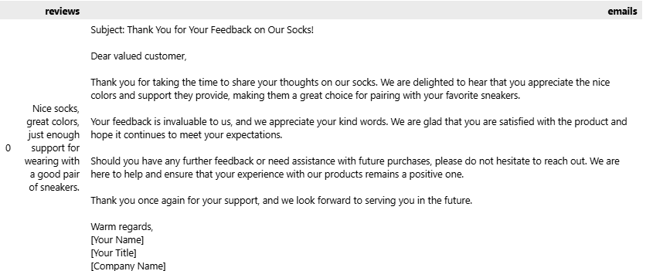

## Task-2 - Generate python code using GPT-3.5 based on a given problem statement.

Sample Problems :

* Primality testing  
  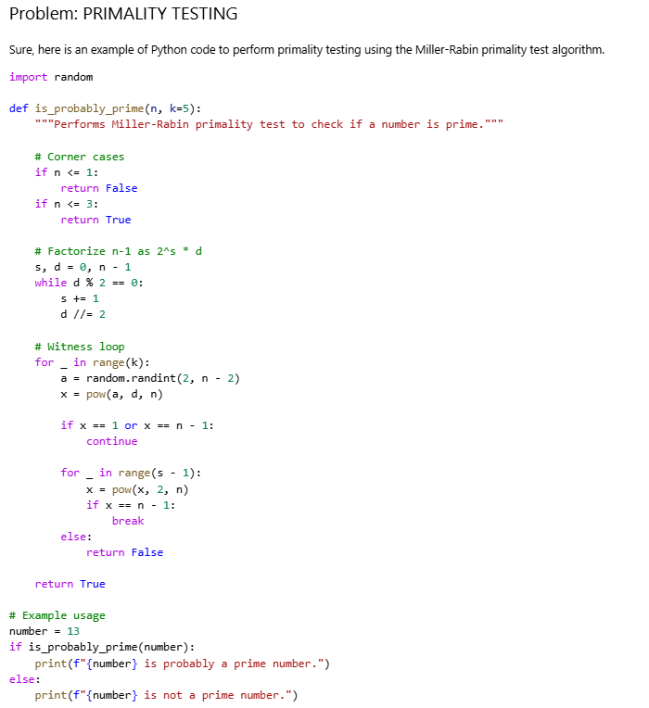
* Sum of unique elements  
  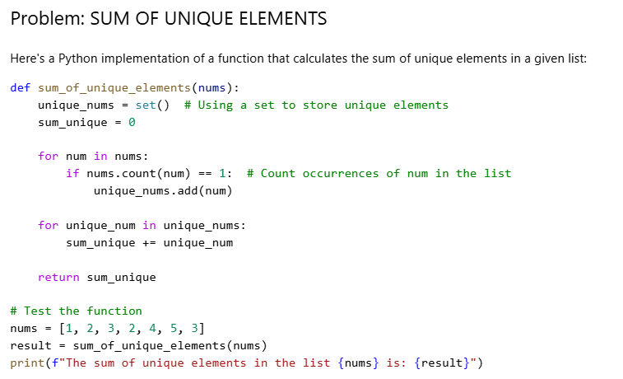
* Longest palindrome  
  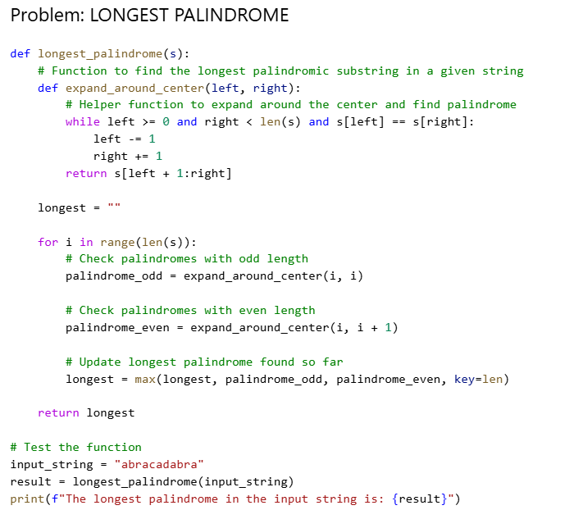
* All possible permutations of a string  
  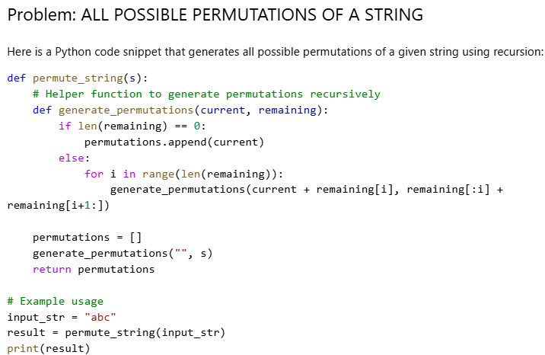

Task-3 Analyze a given research paper PDF and generate summary.  
https://arxiv.org/pdf/1706.03762.pdf

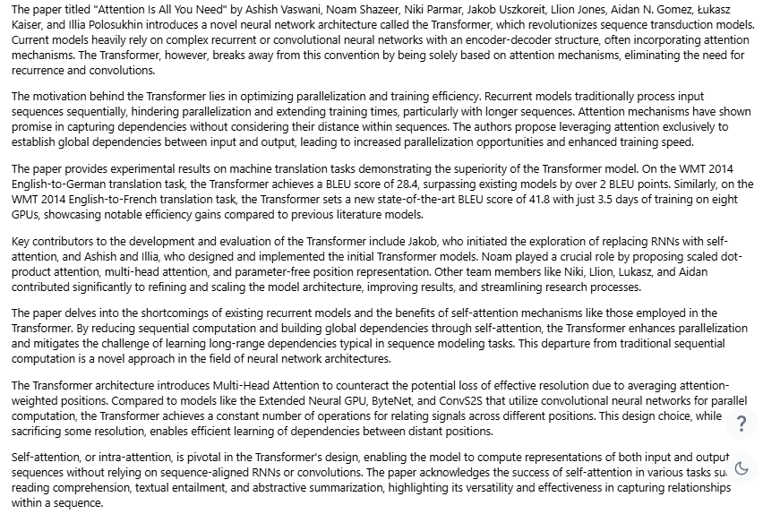

## Task-4 Generate an image of a line drawing for a F-35 fighter.

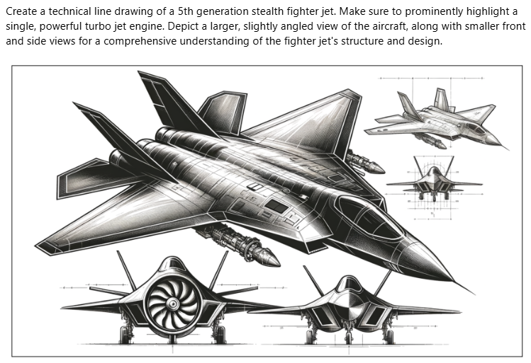

Things I learned :

API Integration

* Successfully integrated the OpenAI API to handle both structured and unstructured data, enabling efficient model prompting and interaction.

Data Manipulation with Pandas

* Leveraged Pandas for advanced data processing, ensuring seamless handling of diverse datasets.

Text Processing and Tokenization

* Explored tokenization and text encoding using the tiktoken library for optimized model performance.
* Employed the pypdf library to extract and process text from PDF files, facilitating document analysis.

Dynamic Content Generation

* Generated diverse content dynamically, including:
  + Sentiment Analysis: Created personalized email responses based on customer reviews to enhance engagement.
  + Python Code Generation: Automated problem-solving tasks with AI-generated Python code.
  + Research Paper Summaries: Summarized complex research papers using OpenAI's language model, making them more accessible.

Image Generation and Visualization

* Generated high-quality visuals using OpenAI’s DALL·E model and integrated them into workflows.
* Managed image handling tasks such as saving, reading from URLs, and presenting visuals through matplotlib.
* Delivered polished visual presentations by customizing displays without axis labels for a clean, professional look.

Task Automation

* Developed and applied reusable functions (e.g., generateMail, generatePythonCode, summarizeText) to automate repetitive tasks, ensuring efficiency and scalability across multiple inputs.